Python Programming
MODULE – V
Agenda:
- Web Programming: Introduction,
- Wed Surfing with Python,
- Creating Simple Web Clients,
- Advanced Web Clients,
- CGI-Helping Servers Process Client Data,
- Building CGI Application Advanced CGI,
- Web (HTTP) Servers

Web Surfing:
In Client/Sewer Computing In client/server computing web clients are browsers i.e., the applications that allow the users to look for the documents on worldwide web.
The web servers are the processes which run on information provider host computers. The client’s send requests to server which processes those requests and returns the data.
Client
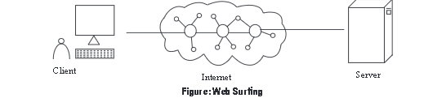
The above figure depicts web surfing where a user runs a web client program like browser and establishes connection to web server on internet to obtain information The requests of clients include form submission, page request or information display. These requests are serviced by the server. The communication protocol that is used by web servers and clients is HTTP. It is a stateless protocol that does not keep track of inform ton from one client request to next It handles even/ request as separate service request including the new requests. Internet Internet is simply referred to a collection of different physical networks such as LAN s, MANs and WANs. These networks are connected with each other in order to transmit the data from a computer on one network to computer on another network. In simple terms it is a network of networks i.e., collection of two or m are networks connected to each other with the help of widely available internet working devices such as router; gateway; bridges etc. The architecture of internet completely depends upon standard TCP/ IP and is designed to connect any the network; irrespective of difference in software, hardware and technical design.
